OUR OFFICES WILL BE THE MEETING POINT FOR THE CITY TOURS OF GIRONA.
MEETING POINT: PUNT DE BENVINGUDA, C/BERENGUER CARNICER 3. GIRONA 17001.
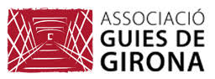
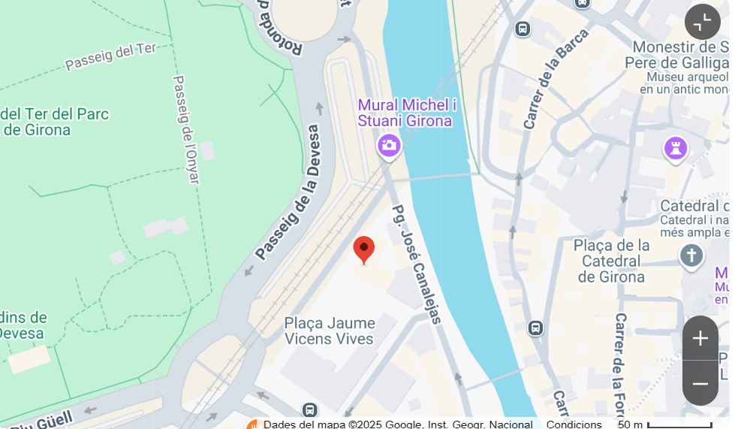
C/ Berenguer Carnicer 3. Girona 17001
(+34) 674 955 805

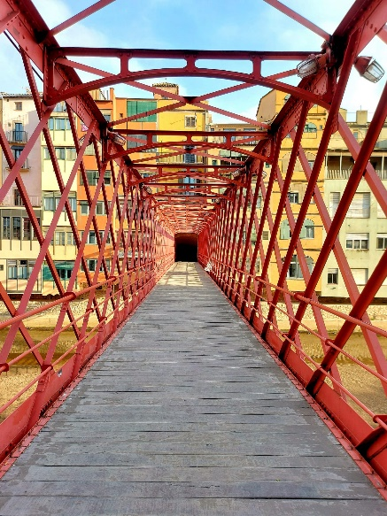
GIRONA THE KINGDOM’S KEY
Visit (no entrances included in this tour) 1.30H
Meeting Point: Punt de Benvinguda
Price 16.00€ adults, children from 0 to 10, free of charge.
Minimum 10 people, maximum 25 people.

Girona was founded 2100 years ago by the Romans.
Walking through the streets where the sixth season of Game of Thrones was filmed, we will discover ancient monasteries, churches, medieval public baths, and the majestic Cathedral. We will walk through the main street of the old Jewish quarter and end the tour strolling through the Gothic guild streets to finish crossing Girona's most famous bridge, do you know which one it is?

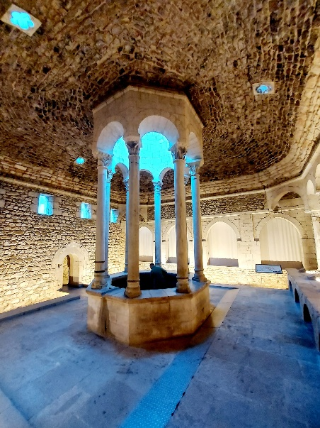
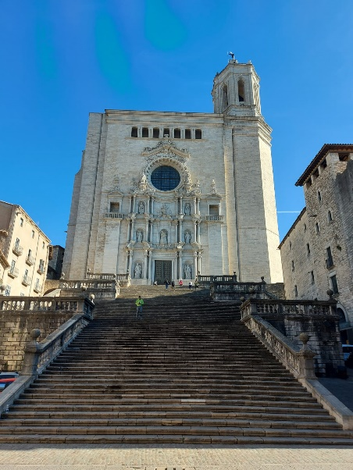
MEDIEVAL GIRONA
Tour including entrance tickets to the Cathedral and the Arab Baths, duration: 2.30 hours.
Meeting Point: Punt de Benvinguda.
Price: €25.00 per adult, children aged 0 to 8 free of charge.
Minimum 10 people, maximum 25 people.

During this visit, we will not only walk along the city's streets, which according to legend was conquered by Charlemagne, but we will also visit two unique buildings inside: the Arab Baths and the Girona’s Cathedral. The latter is unique worldwide for its treasures, which include a 13th-century stained glass window, an 11th-century embroidery, and the widest Gothic nave in the world.
Did you know that Charlemagne was venerated as a Saint in Girona Cathedral?

JEWISH GIRONA
Tour including entrance to the Museum of Jewish History, 2.00 hours.
Meeting Point: Punt de Benvinguda.
Price: €20.00 per adult, children aged 0 to 8 free of charge.
Minimum 10 people, maximum 25 people.

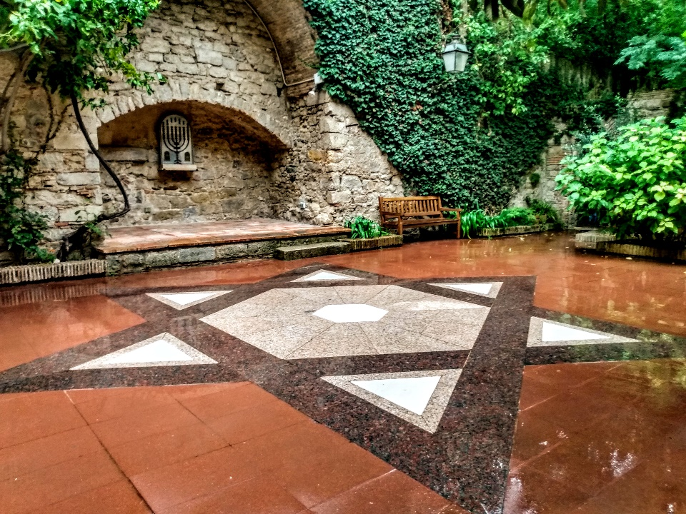
Even today, Girona is known by the name; "Mother City of Israel."
From the 9th to the 15th century, Girona had an important Jewish community, the second most important after Barcelona. We will walk along the streets where the community lived and from where they were expelled on July 31st, 1492. We will visit the last known synagogue and its mikveh.
Do you know who Ramban was? What was the Kabbalah? And the Inquisition?

PALS: MEETING POINT
PLAZA MAYOR JUST IN FRONT OF THE TOWN HALL
Pals 17256
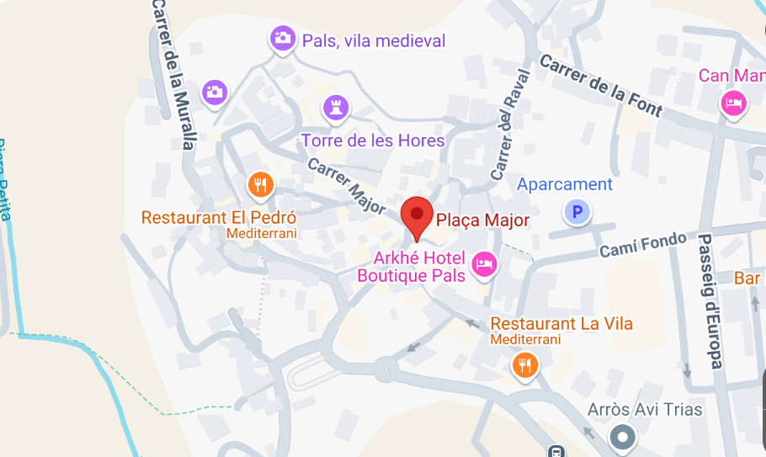

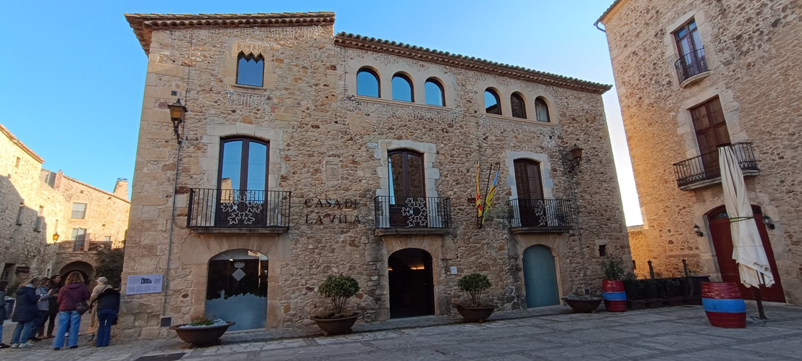
PUNTO DE ENCUENTRO
AYUNTAMIENTO

WHEN WALLS SAVED LIVES
Pals
Visit 1.30H (no entrances included in this tour).
Meeting Point: Plaza Mayor, in front of the Town Hall. Pals 17256
Price: €16.00 per adult, children aged 0 to 10 free of charge
Minimum 10 people, maximum 28 people

In the past, Pals was a small medieval village surrounded by walls. Walls and towers that we can still see today, defensive walls with towers and bastions, where armies were stationed to defend the population. As important as the walls were the castle or the church. How it was medieval life like within the walls?

BESALÚ MEETIG POINT
IN FRONT OF THE "ELS JARDINS DE LA MARTANA" HOTEL (RIGHT BY THE BRIDGE, NEXT TO THE TOURIST OFFICE AND THE PUBLIC RESTROOMS).

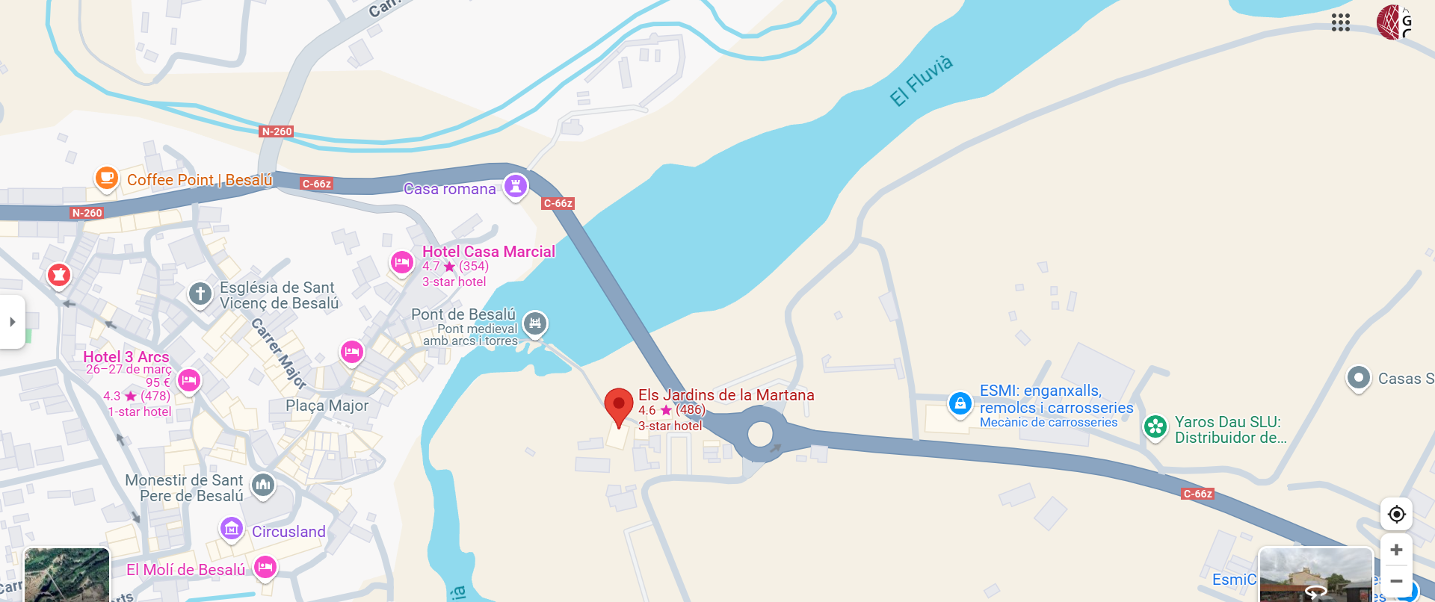

BESALÚ. BETWEEN JEWS AND CHRISTIANS
Tour includes entrance fee to the Mikvé, 1:30H / 2:00H
Meeting Point: In front of "Els Jardins de la Martana" Hotel (by the medieval bridge, next to the tourist office and public toilettes)
Price €18.00 per adult, children aged 0 to 8 free of charge
Minimum 10 people, maximum 28 people

In Besalú, we will be able to admire one of the most spectacular medieval bridges in the world.
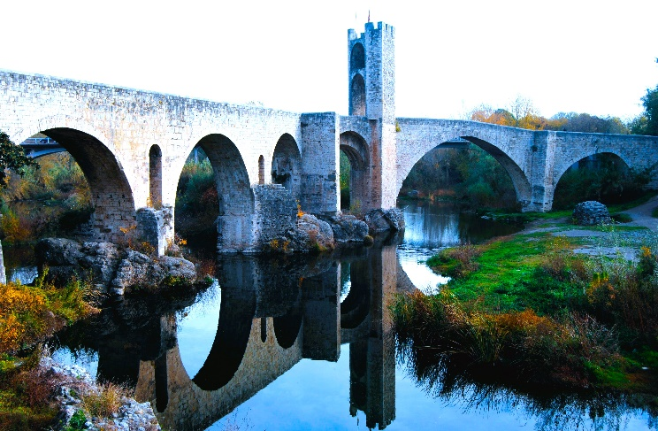
There was a time when Jews and Christians lived together and at the same time, at the same village but in different places, the Torah and the Bible were read. We will visit El Call, where the Jewish community lived, the area where they had their synagogue, and we will enter the Mikvé, one of the best-preserved in Europe. The Jewish community of Besalú was known for training the best doctors in the Kingdom.
El Call was located very close to the Monastery of Sant Pere and the Hospital of Sant Julià, where hospitality was given to pilgrims passing through the Villa.

BANYOLES MEETING POINT. PESQUERA 10, PASSEIG DARDER, 30. 17820 BANYOLES GIRONA.
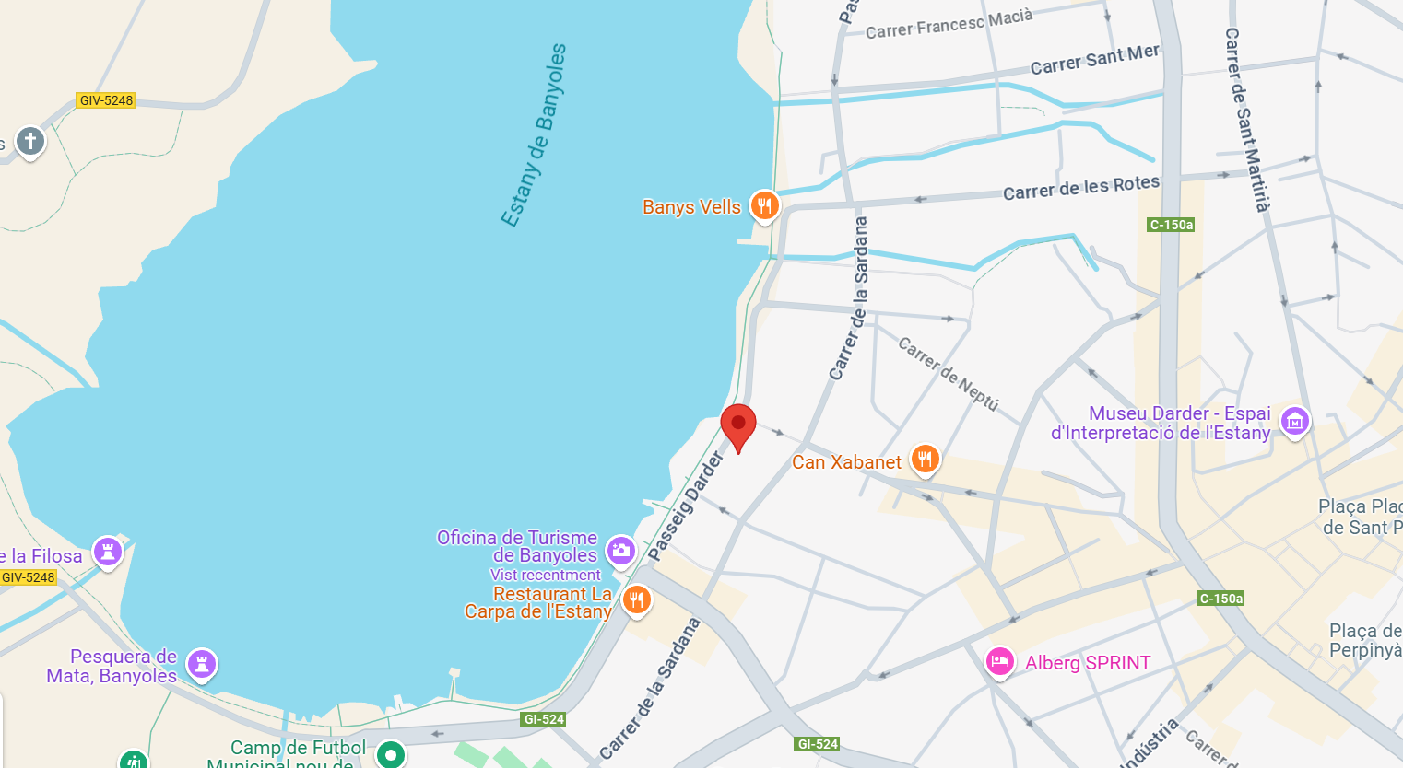

BANYOLES, WATER AND LIFE
Visit without tickets, 1.30H. (no entrances included in this tour)
Meeting Point: Pesquera. 10, Passeig Darder, 30, 17820 Banyoles, Girona
Price €16.00 per adult, children aged 0 to 10 free of charge
Minimum 10 people, maximum 28 people.

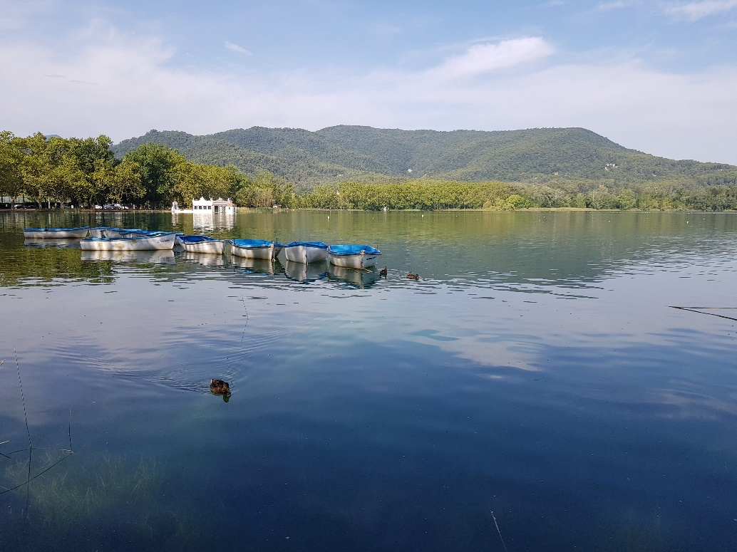
Since ancient times, humans have settled around the great lake of Banyoles; from the Neolithic era to the first Benedictine monastic foundation in Catalonia, which built artificial channels, the reason for the growth and wealth of this medieval industrialized city in modern times and the venue for the rowing section of the Olympic Games in 1992.

FIGUERES. MEETING POINT FOR DALÍ’S MUSEUM TOUR
SCULPTURE HOMAGE TO FRANCESC PUJOLS JUST IN FRONT MUSEUM ENTRANCE

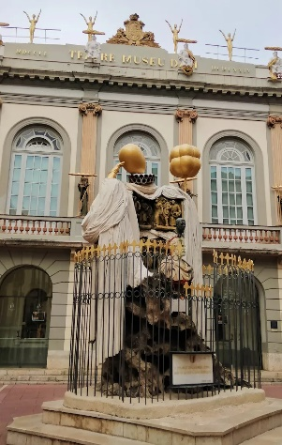
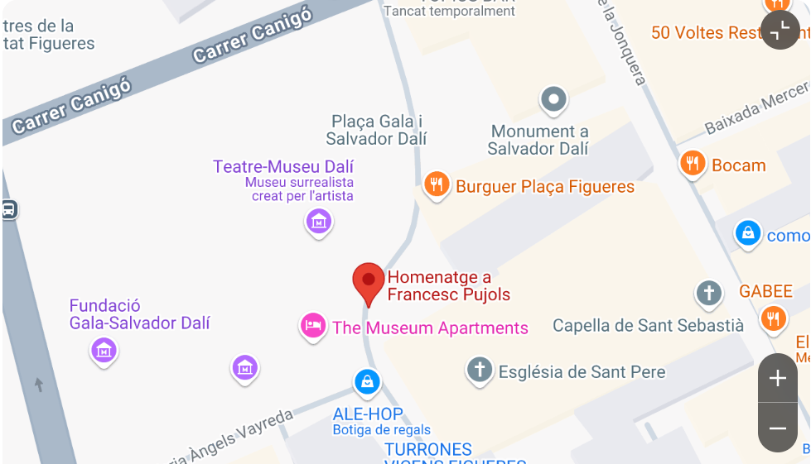

DALÍ ALPHA AND OMEGA, THE BEGINNING AND THE END
Figueres visit Salvador Dalí’s Theatre-Museum
Visit with tickets included, 2:00H
Meeting Point: sculpture Homage to Francesc Pujols in front of the Theatre-Museum entrance.
Price: €30.00 per adult, children aged 0 to 8 free of charge.
Minimum 10 people, maximum 24 people (+1 official guide).

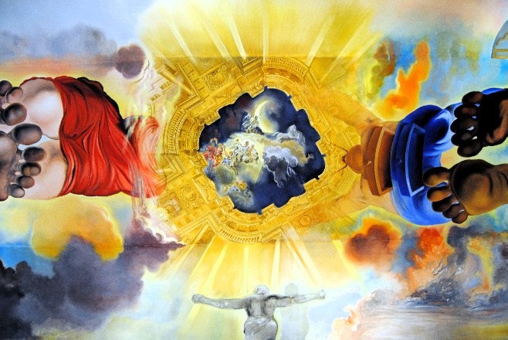
Figueres is the Dalí’s birthplace, and where he lived his last years, also the place where his tomb is located. Therefore, we can say that it is the beginning and the end, the Alpha and the Omega of Salvador Dalí.
In Figueres, Dalí left his last work, the most surreal, his Theatre-Museum, the place where he held his first exhibition and the project he worked on during the last years of his life, when he was already affected by a disease that made it very difficult for him to paint. Do you know which disease it was?
The guided tour will make you discover Dalí's vision, the double images, fun and hidden in every corner of the museum.

